 | 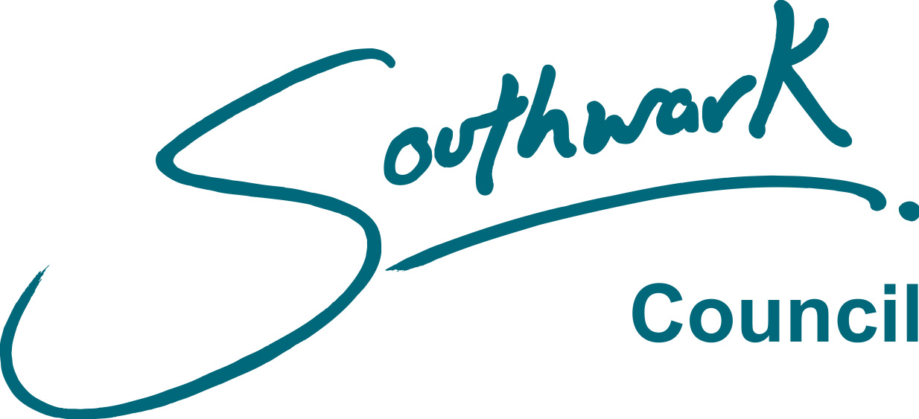
FORM PEN 01
Rev Dec 2015

LONDON BOROUGH OF SOUTHWARK

Local Government Pension Scheme Regulations 2013

Details of New Entrant

You will be contractually enrolled into the LGPS on your first day of service under the provisions of the above scheme and the Pensions Act 2008. We need you to complete this form to provide us with the information to be able to set up your pension account.

Although enrolment in the scheme is automatic, membership is not compulsory, so if you decide you do not want to be in the main scheme other options are available;
- 50/50 Section You can pay 50% contributions for 50% of the pension benefit by completing a PEN05 form
- Opt out You can elect to leave the pension scheme by completing a PEN04 form

To either join the 50/50 Section of the scheme, or to opt out, you will have to request the relevant form from Pensions Services (see foot of page) and sign it on or after your first day of service. Please note that current legislation requires all employees to be re-enrolled into the main scheme every three years from the employer’s original staging date.

The minimum amount of membership that a member needs to qualify for benefits under the scheme is two years.
Details about the benefits and costs of membership can be found at www.lgpsmember.org

PLEASE ATTACH A COPY OF YOUR BIRTH CERTIFICATE OR PASSPORT.

Surname |  | Mr | Mrs | Miss | Ms
Forenames |  | NI Number
Previous surname (if applicable) |  | Date of birth
Home address
Post Code |  |  | E-mail

Job title (if you are employed by Southwark in more than one job, please give details of all jobs in this space)

Work location or name of school | Date started current employment with Southwark
If you have previously been employed by Southwark, please state dates and whether you were in the pension scheme:

If you were in a previous employer’s pension scheme please read and complete the sections about transferring your pension rights on pages 2 and 3 of this form.

Page 1

FORM PEN 01
Rev Dec 2015
MARITAL/PARTNERSHIP STATUS (please tick the appropriate box below)

 | Married or a Civil Partner (please enclose photocopy of certificate) |  | Widow(er) or a Surviving Civil Partner
 | Divorced or previous Civil Partnership dissolved |  | Single
 | I have a co-habiting partner that I wish to receive a pension after I die. A registration form will be sent to you.
Complete this section only if you have previously been a member of the Local Government Pension Scheme

(a) If you have not had a refund of your contributions you may can consider transferring your service to us.
(please complete one of the boxes in the next section)*.

(b) If you were previously paying additional contributions to increase your retirement benefits, do you wish to
To continue these payments?
YES NO (tick as appropriate)
(c) Are you receiving a pension from any Local Authority?

YES NO (tick as appropriate)
If yes, please give details

*Benefits from other Local Authorities will, generally, be automatically transferred to this membership, although you will have 12 months to decide if you want to keep them separate - we will provide you with more information about this choice once we have contacted the earlier employer. Please be sure to list them on Page 3.

Do you have any pension entitlements with any other pension scheme or personal pension plan that you would like to consider transferring to Southwark’s Scheme?

Please tick the appropriate box YES NO

If yes, please complete the accompanying form NPF01B ‘Transfer of Pension Rights’.

Note: If you currently contribute to a personal pension plan or stakeholder pension scheme, you should immediately inform the administrators of your personal pension plan or stakeholder pension scheme that you have joined your employer’s contracted-out occupational pension scheme.
I declare that the information provided in this form is correct to the best of my knowledge:
Signed: |  | Dated:

Our secure on line pensions system now allows you to:
• View and update personal details and changes of address
• Find out how much you will receive on retirement
• Calculate the amount of additional lump sum you can take on retirement
• View your service history, including any service which has been transferred
• View your nominated beneficiaries
use the link provided to register today: https://pensions.southwark.gov.uk

Page 2
FORM PEN 01
Rev Dec 2015

LONDON BOROUGH OF SOUTHWARK

Local Government Pension Scheme Regulations 2013

Transfer of Pension Rights

Please provide details below if you are interested in transferring your previous pension rights from another occupational/personal pension provider to this scheme. When information has been received from them we will present you with your options and an election form, you will not be allowed to transfer in service, from any source, unless you elect to do so within 12 months of joining the pension scheme.

Name & Address of Company, Public Body or Local Authority providing pension benefits you may wish to be transferred | Dates of scheme membership/  Dates contributions paid from/to | Reference / Policy No

Authority to release information in connection with previous pension rights

Full Name:
Date of Birth: |  |  | NI Number:

I authorise Southwark Council Pensions Services to act on my behalf in connection with my previous accrued
pension rights. Once we receive information about your former pension arrangements we will write to you with the options available and ask you to make an election. Your benefits will not be transferred unless you make that
election with 12 months of joining Southwark Council’s pension scheme. You are not electing to transfer by signing this
form.

Signed: |  | Dated:

Page 3

